ACTIVITY REPORT 2018-19
World Environment Day was celebrated by students planting the saplings in the school campus. They also took the oath to keep their environment clean.
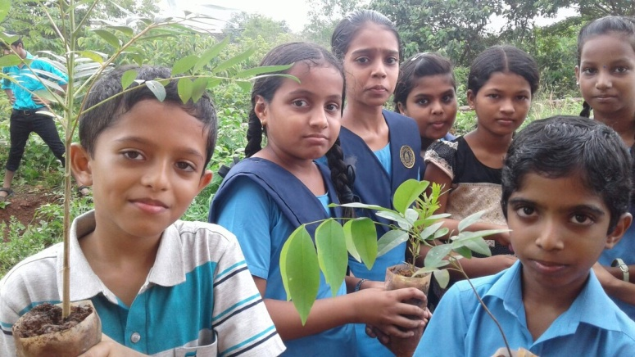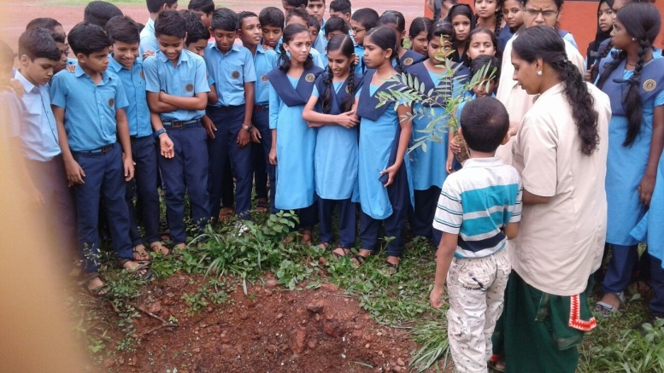
Reading Day was observed on 19 June.
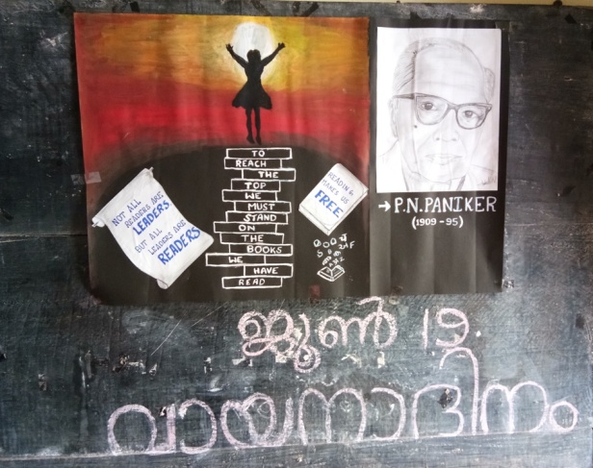
Students spoke about the importance of reading.

27th & 28th June, 2018 Kairali Books Pvt. Publishers organized book fair in the school . Dr. Renjeev, Secretary BVB inaugurated the Book Fair.
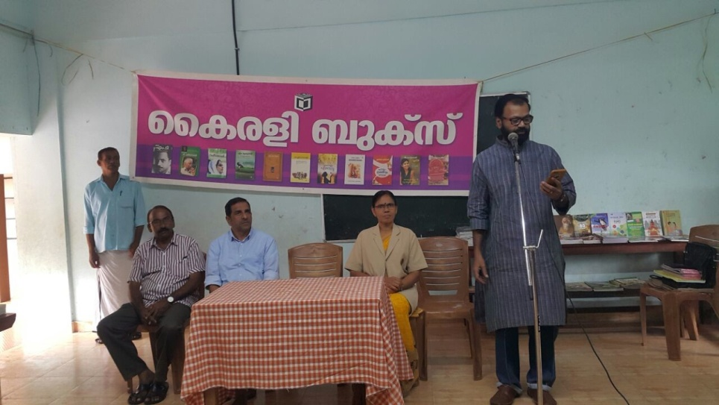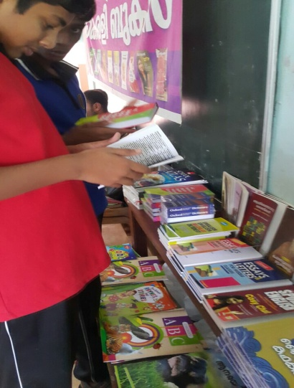
International Day of Yoga celebrated on 21 June as well as the International Day against Drug Abuse and Trafficking.
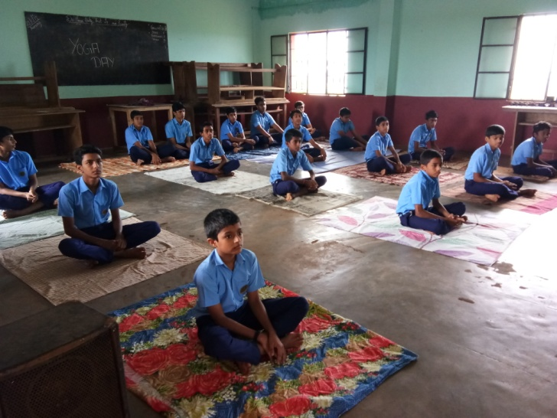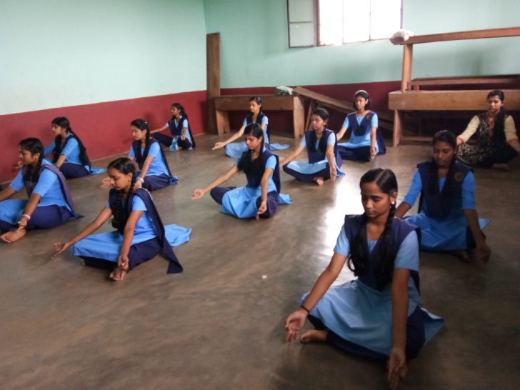
To develop reading habits in children Vayana Kalari, Manorama was introduced. Mr. Vijay Neelakandan (Socio-Eco Environmentalist) sponsored 20 Manorama papers in memory of his Late. Grandfather Company Swamy Sri. P Neelakandan Iyer.
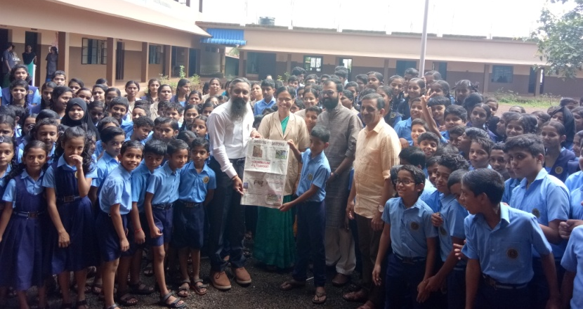

On 16th October Food Fest was organized for the students as part of World Food Day. Students prepared variety of dishes and displayed it in a neat and attractive way.
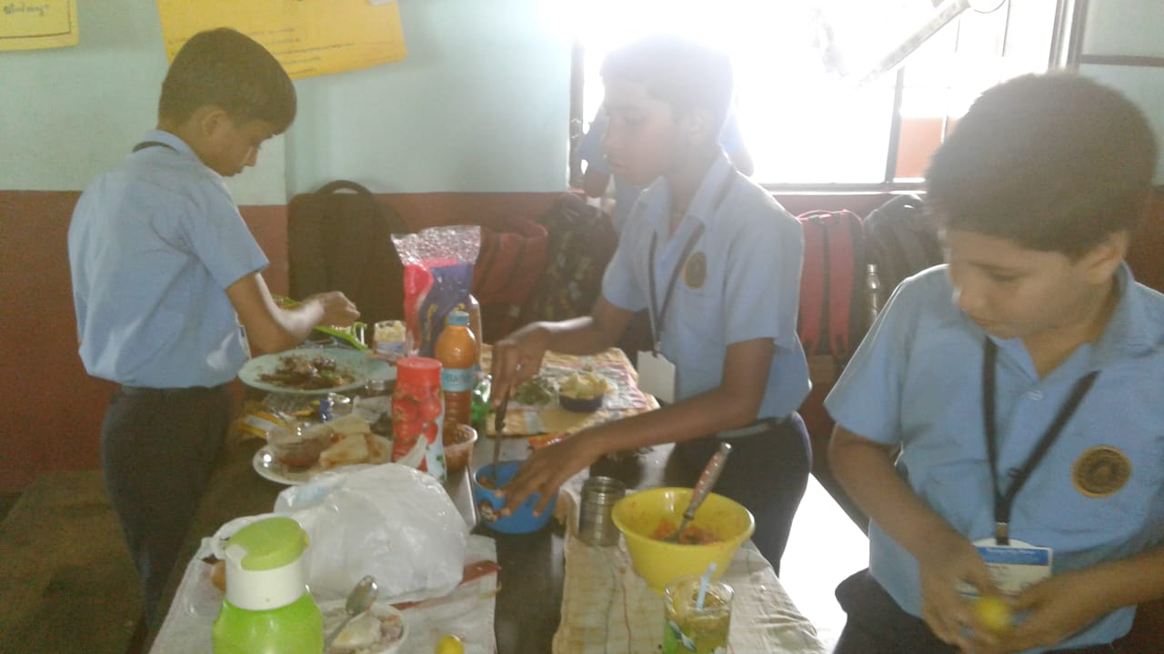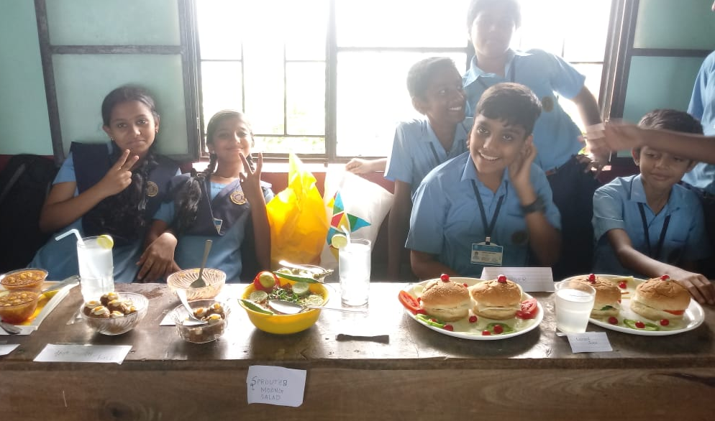
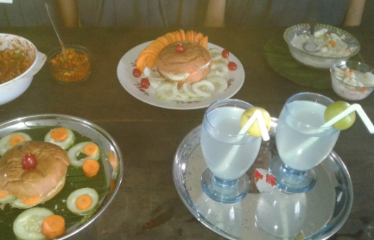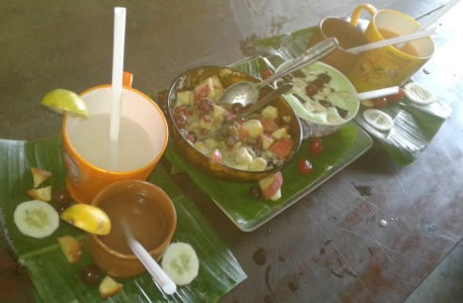
Hindi Diwas was celebrated on 14th September 2018. Students prepared skit showing the importance of ‘Rashrabhasha’.
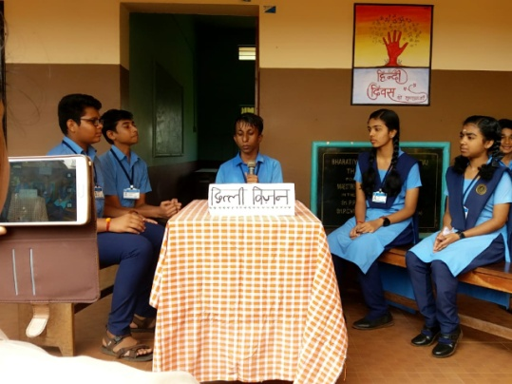

On Keralapiravi special assembly programme was conducted showing the importance of ‘Mathrubhasha’.

Childrens Day was celebrated as a grand programme with their parents and grand parents.

Awareness/ Motivation Class
Prof. E Swaminathan, Mumbai conducted an interactive session with the students of VIII-XII Std. on the topic ‘Science of Memory and Concentration’ on 10th July 2018.
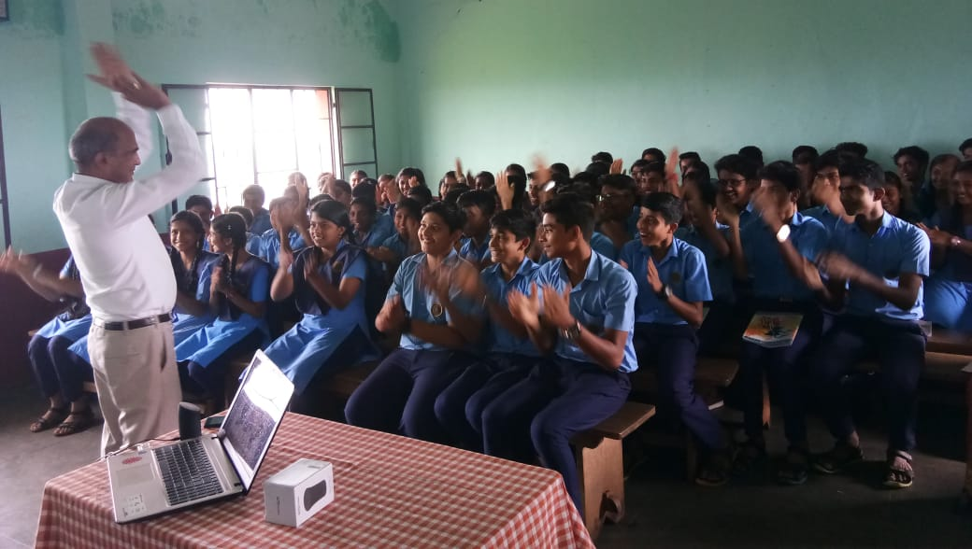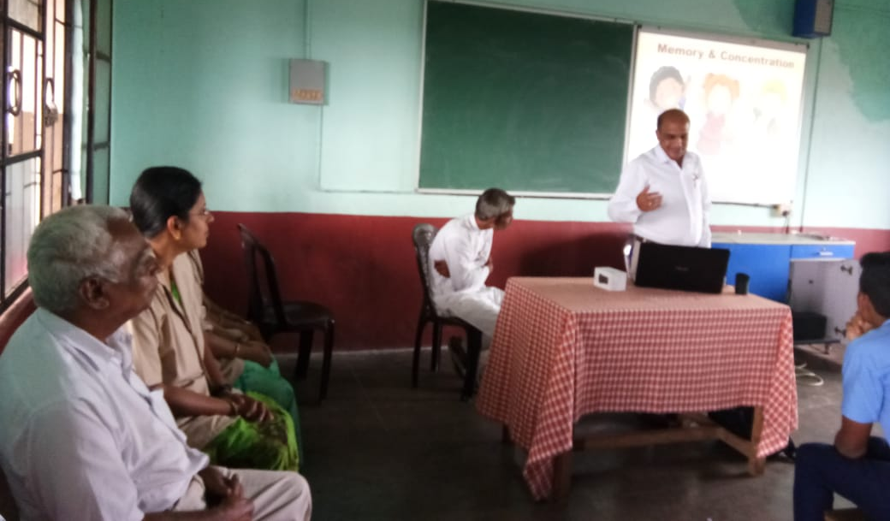

On 15th September 15,motivation class was conducted by Mr. Soumyendran K for students of Class I- XII as ‘Drishyam Manoharam’ and for Parents as ‘Thiricharivinte Vazhikal’.
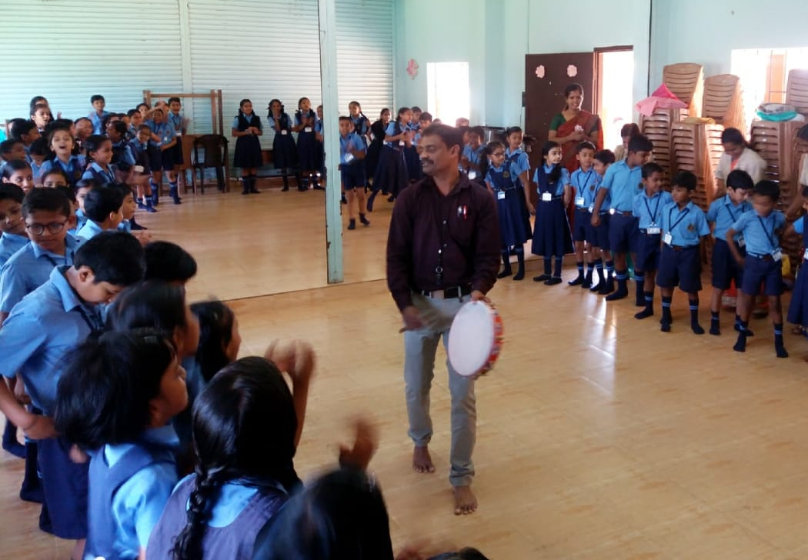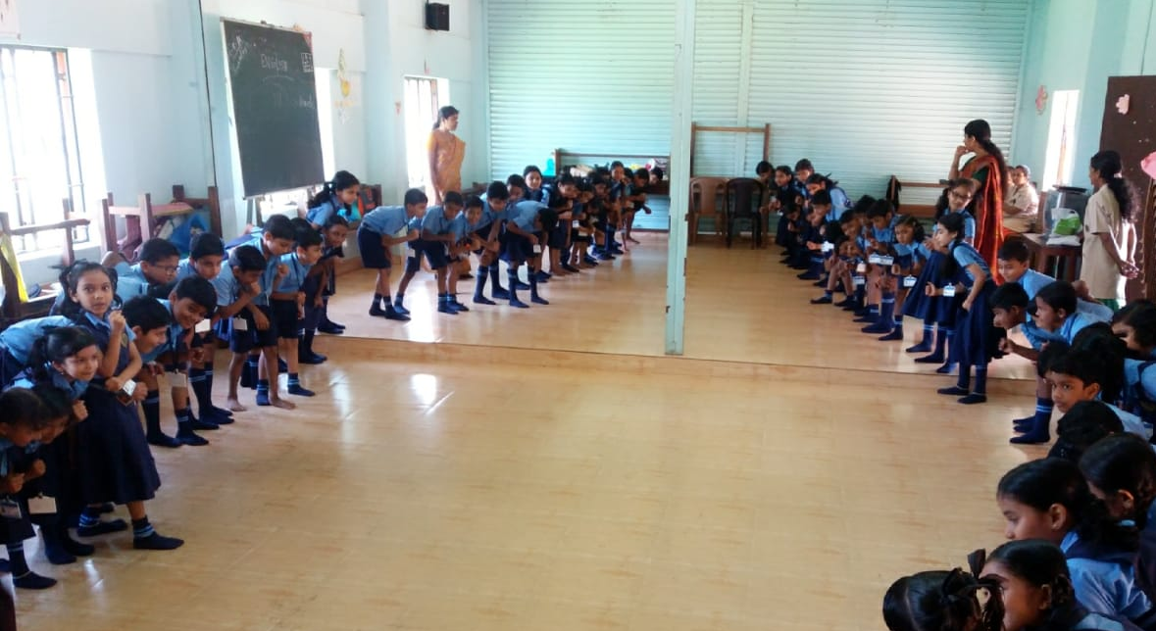
Cyber Awareness by Sri. Rouf, Trainer on Cyber loss was given to the students of VIII-XII Standard on 28th November 2018.

SPORTS

Facilities available for playing Football, Volleyball, Shuttle Badminton, Cricket, Athletics, Jumps, Throws, Kho-Kho and indoor games Chess and Carroms.

On July 11th & 12th our students Akshara P and Navya Nambiar (XII Std) participated in the Sahodaya Shuttle Badminton U-17 at Koothuparamba. They played the semi finals.
Sreelakshmi P and Neha (XII Std) received the First Runners-up Trophy, Silver Medal and Certificates in the U-19 category.
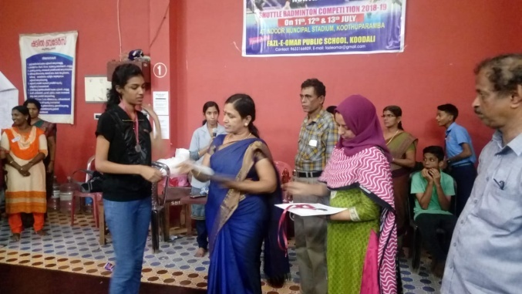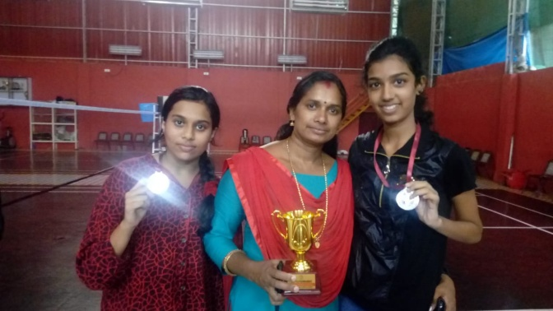

There are four houses in the school. Inter house competitions are conducted: Athletics, Jumps and Throws for Classes III-XII was conducted on the Sports Day on 9th November 2018.
Blue house received the Overall Trophy followed by Green, Red and Yellow.
This year the medals were awarded on the Children’s Day by the Grand Parents and the parents.
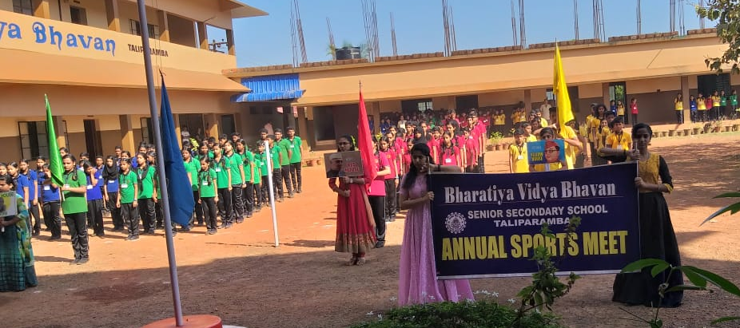
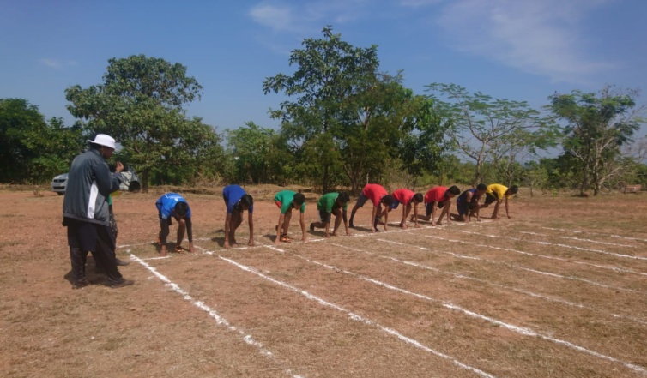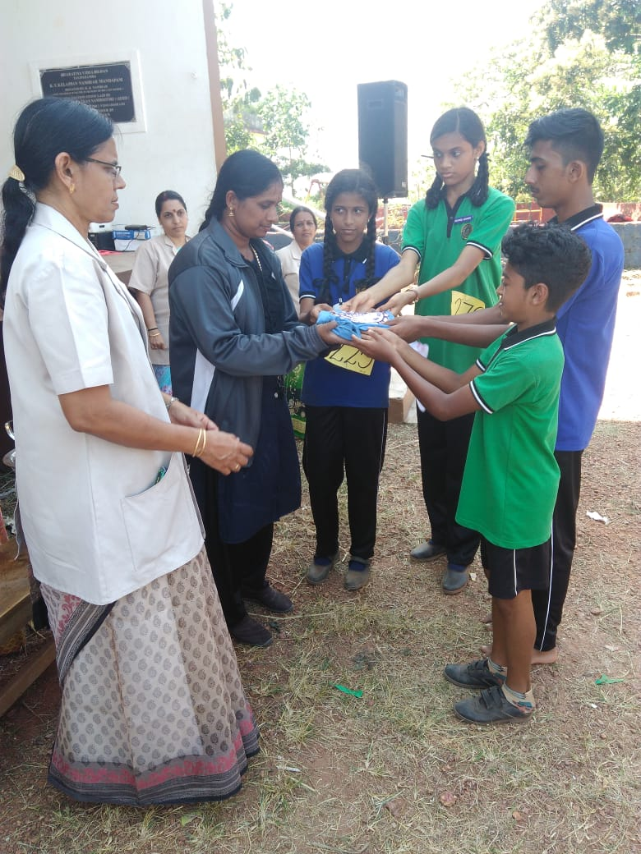

Societal Contributions by Institution/students
- Our students donated Rs. 10,000/- to Thapas – Thanal, Dialysis Centre, Taliparamba, from the charity box where every Wednesday our students drop in a valid coin.
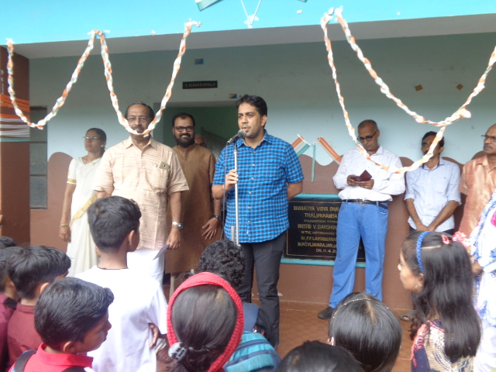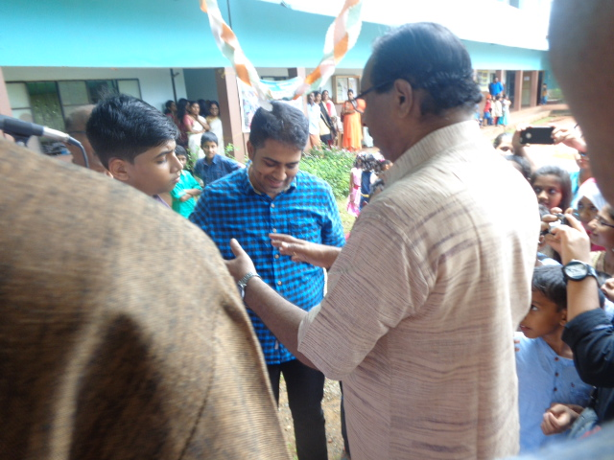

- Our school joined hands with the District Collector Sri. Mir Muhammed Ali on the mission ‘Clean Kannur, Green Kannur’. The project named ‘Collectors@School’ is a sustainable plastic waste management scheme implemented through Kinder Garden to XII Std. Our students and staff enthusiastically participated in this programme.

- The students and teachers collected the used clothes which can be reused by somebody. Under the auspices of Taliparamba Municipality Suchithwa Mission and Haritha Karshakasena, ‘Haritham Madhuram - Swap Shop’ was inaugurated by the District Collector Sri. Mir Muhammed Ali, IAS presided by the Municipal Chairman Sri. Allamkulam Mahamood. Our students and teachers participated in it and had a great experience.
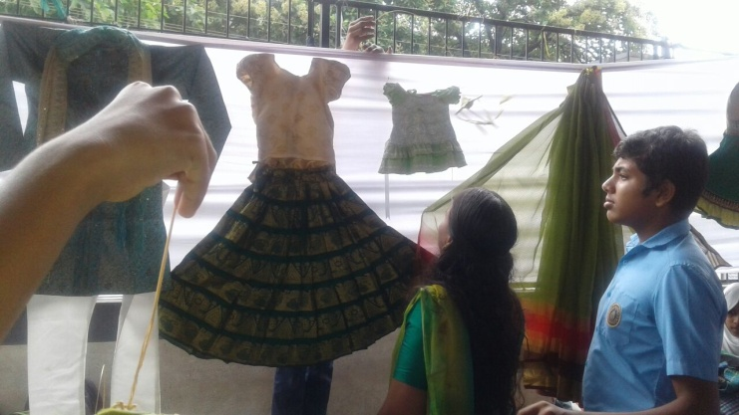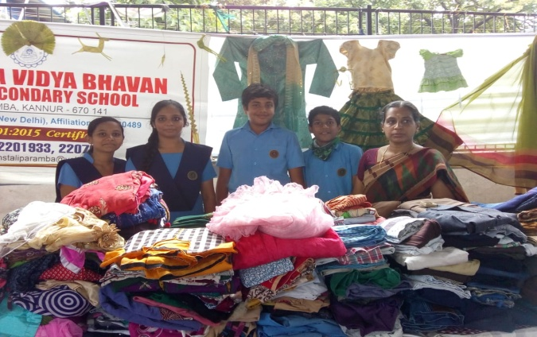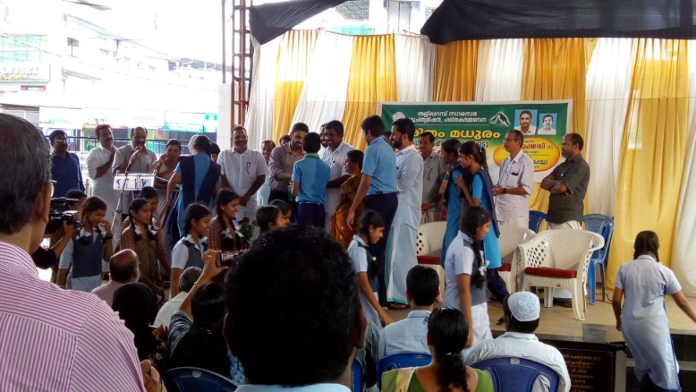
- Handed over the cheque for the Chief Minister’s Flood Relief Fund to the Tahasildar, Taliparamba. Our students collected study materials and donated it to the students of the flood affected areas under the auspices of Matrubhumi.
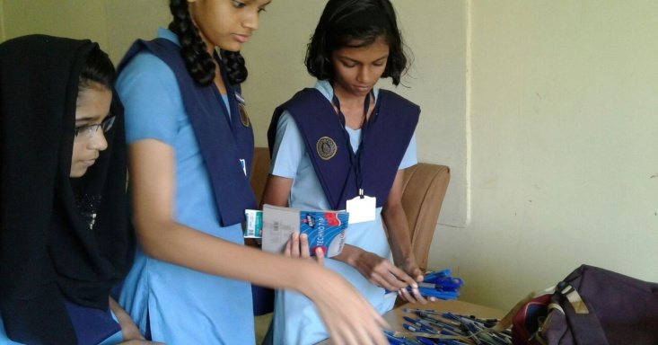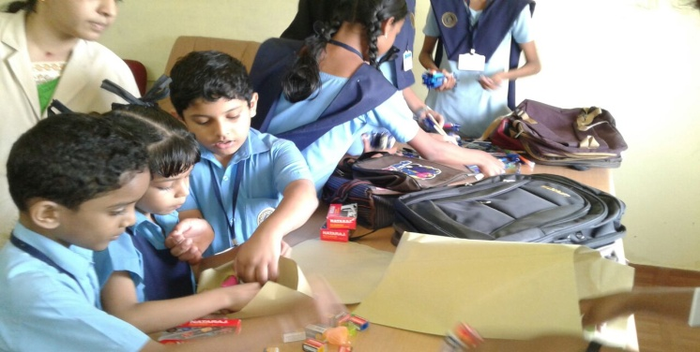

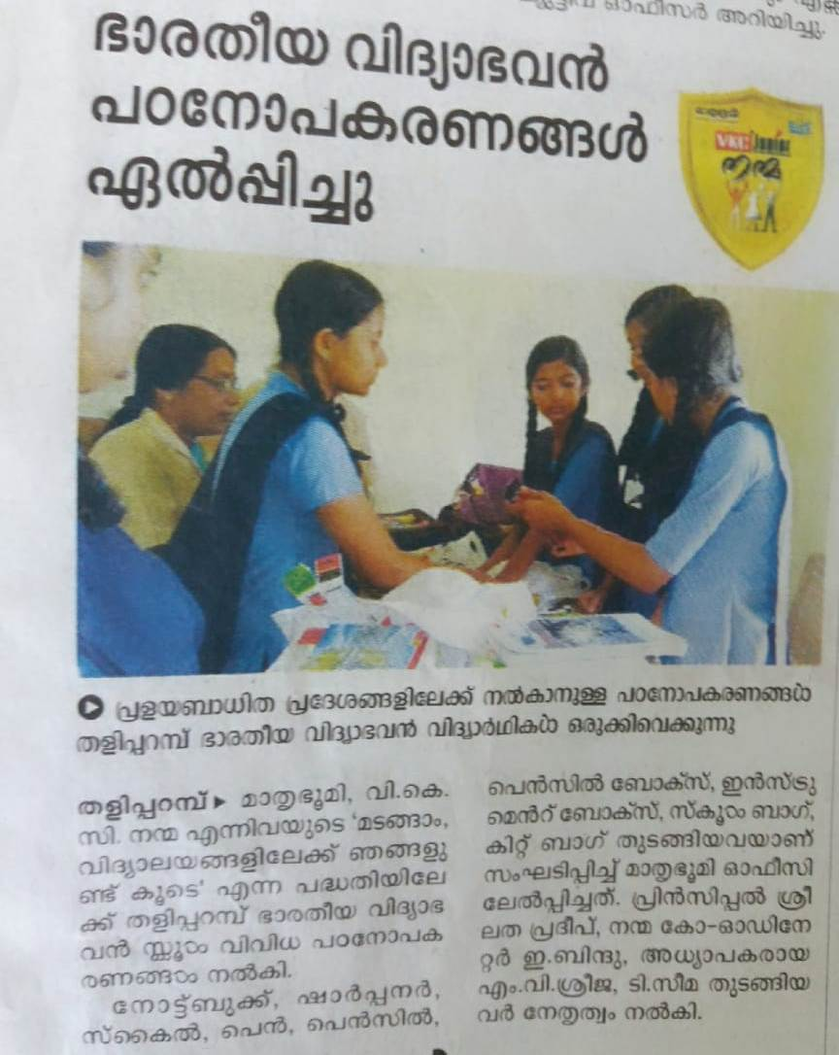

- On 1st October 2018, our students participated in the rally organized by Taliparamba Municipality as part of ‘Clean Kerala’ Programme.
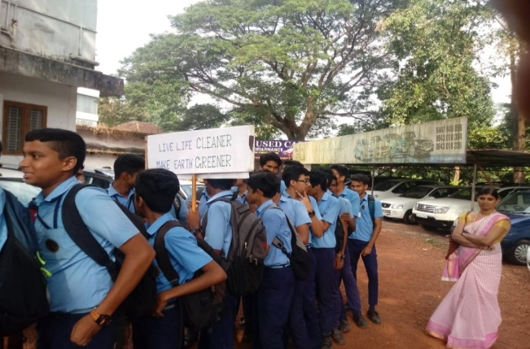

The campus was cleaned by the students and the staff as part of ‘Sevana Varam.’
