ACTIVITY REPORT 2019-20

Annual Event
This year’s events started with the observation of the World Environment Day on 5th June, giving importance to the presence of plants , its conservation for a healthy environment.
The election of the Student Council was held on 2nd August. Gopikrishna P V (XI) was elected the School Leader. The Investiture Ceremony was held for the newly elected members. It instilled leadership qualities in students. All the days of importance are celebrated with gaiety.
Onam was celebrated in the school on 4th September 2019 as well as the Teachers Day. Various programmes organized by the students, made the day a memorable one reminding everyone the nobility of teaching profession.
The PTA of 2018-19 honoured the top scorers of each class with proficiency prizes as well as the students having the maximum attendance.
14th November was celebrated in the school as the Grandparents Day and 21st Annual Day. Several cultural programmes were organized based on the theme’ Rising Kerala’.
Constitution Day was observed on 26th November.

Co-curricular Activities
Literary and offstage competitions were conducted in English, Malayalam and Hindi. Students participated in the Kannur Sahodaya School Complex, Literary, Offstage and Cultural competitions.
Tejaswini B S (XII) secured 1st position in Category IV Malayalam Story Writing.
Nived N Kumar (VII) secured 2nd position in Category II Classical Music (Boys) and Light Music (Girls).
They both were selected for the State Fest to be held in Vazhakulam.
Saketh (VIII) secured 3rd position in the Digital Painting.
Students participated in the Bhavan’s Fest held at Chithali,( Palakkad)and Thrissur.
Our students appeared in the Sahodaya Talent Search Examination on 5th November 2019.
They will also participate in the Bhavan’s Scholarship Exam.
Students are motivated to participate in the competitions conducted by the other organizations too.
Sports and Games
The 21st Annual Sports Meet of the school was held on 8th November 2019 in the school ground. Red house became the overall champions and Green house – the 1st runner up followed by Blue and Yellow house.
Inter house Football competition and Shuttle badminton was conducted.
Our students participated in the Sahodaya Chess Tournament, Shuttle Badminton and Football tournament as well as the Athletics.

Teachers Enrichment Programme
With a view to equip teachers with the necessary skills and techniques for effective classroom teaching, several subject teachers attended workshops conducted by the Kannur Sahodaya. Capacity Building Programme of CBSE on Career Counselling and Health and Physical Education as well as workshop organized by the publishers. PET attended the training programme of the Khelo India at Calicut.

Students and Parents Enrichment Programme
An orientation programme for parents-Adolescent behaviour was organized on 19th June. Dr. Harsha Haridas (MBBS, MD, Psyychiatry) handled the session. Sri. C C Ramakrishnan, National Trainer handled a session on improving Learning Skills for the students of VIII to XII on 4th October 2019.

Social Activities
Sr. Executive from KSEB gave the importance of keeping oneself safe during the heavy rains while taking care to use the electrical equipments, damage in the electric lines. The awareness was given to the students to educate the people in the surroundings and family.
This year again, when the flood struck disaster in Kerala and in our neighbourhood, our students rose to the occasion. They provided food materials and essentials to the 40 families of Korlai Thuruthu of Sreekandapuram on 20th August 2019.
Sunrise hospital conducted an eye camp in the school for our students on 10th October 2019. The Swatchatha week was celebrated. Children helped in cleaning of the campus as well as pledging to reduce the use of one time plastics. On this occasion, poster making competitions recycling plastic, best out waste was organized.
Special Assembly programmes were conducted on the Reading Day, Moon Day and such days of importance organized by the Literary club, Science club, Heritage club.
Food Fest was organized for the students of III to XII to hone the culinary skills of the children as part of the World Food Day on 18th October.
Visits and Picnics
Going beyond the classroom walls and textbooks -- to gain knowledge and experience along with fun, study tour had been organized for students of IX to XII to Wagamon and Eranakulam from 4th – 7th December 2019. Other classes will have one day picnic.

ACTIVITIES 2019-20

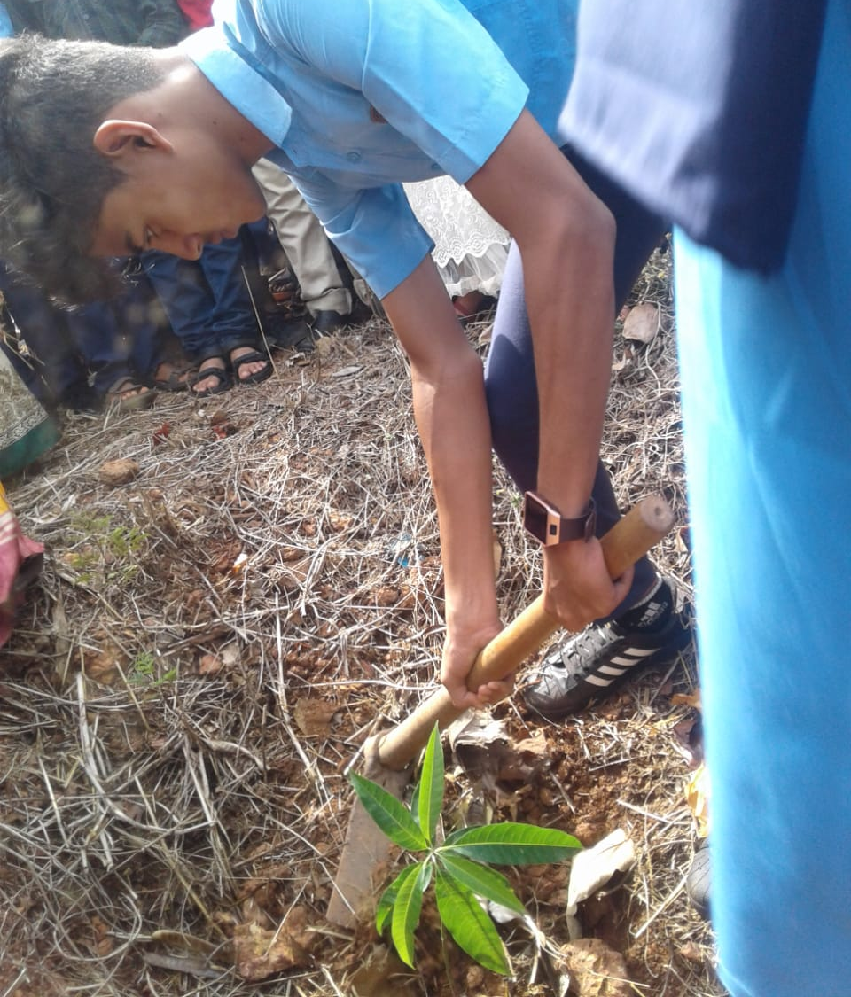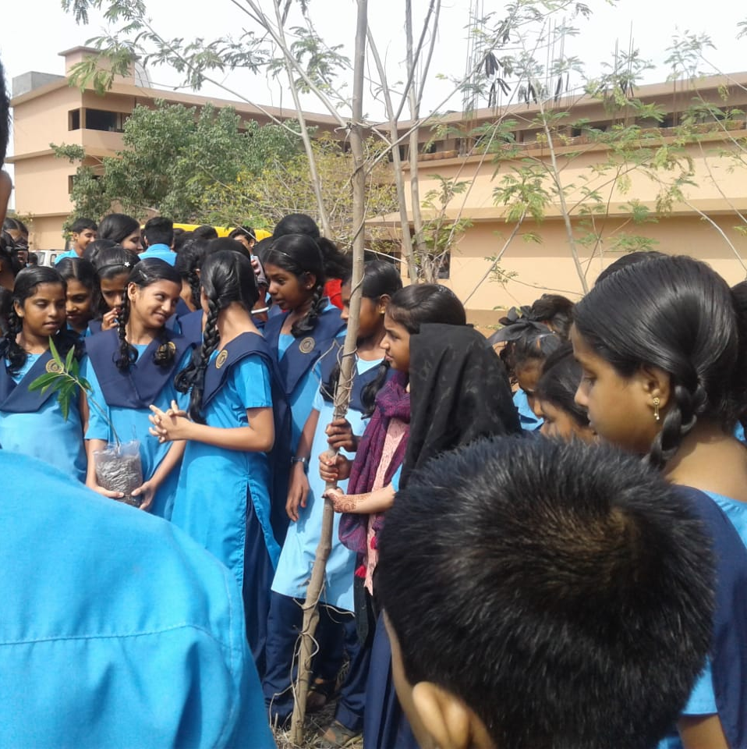
Environment Day

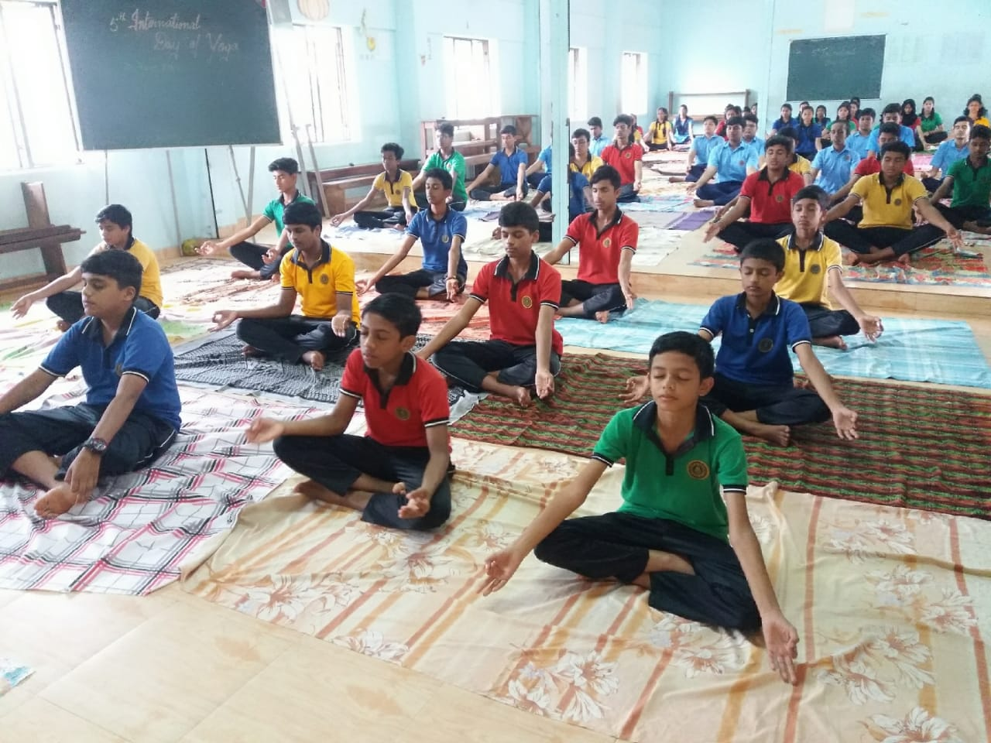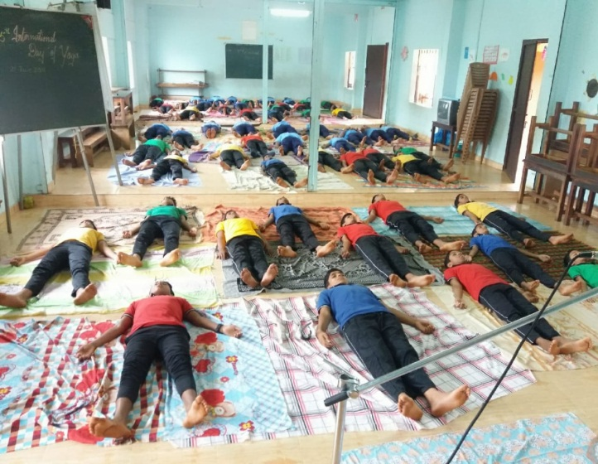
Yoga Day
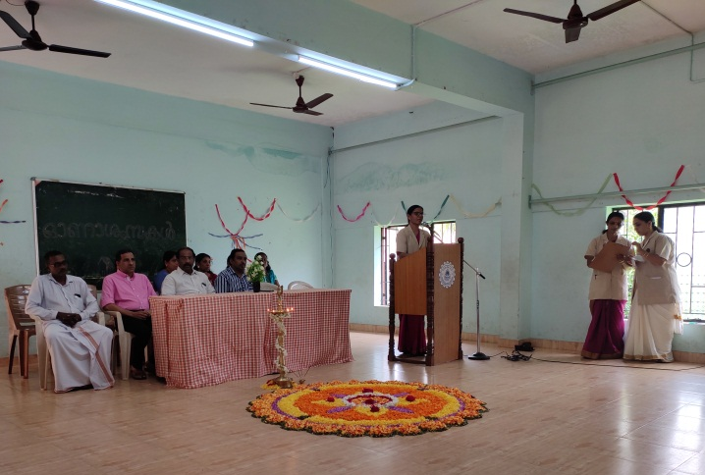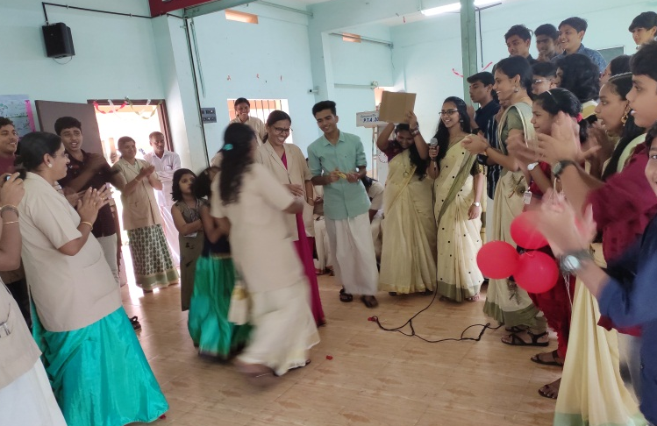
Onam & Teachers Day Celebrations
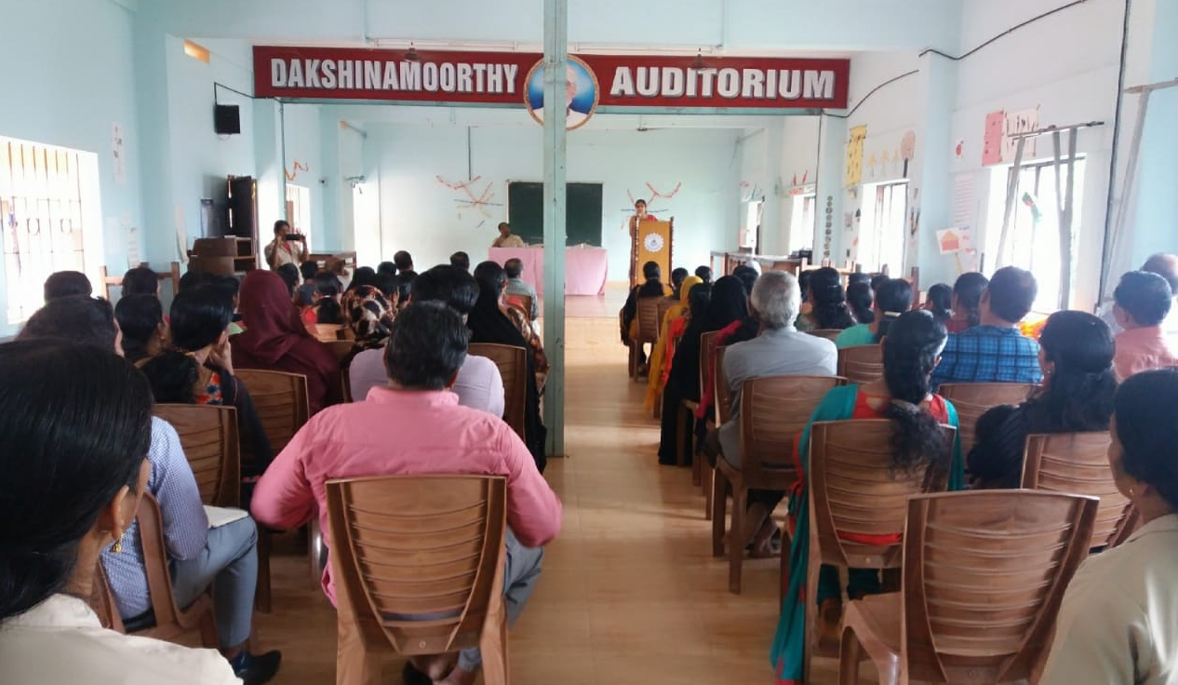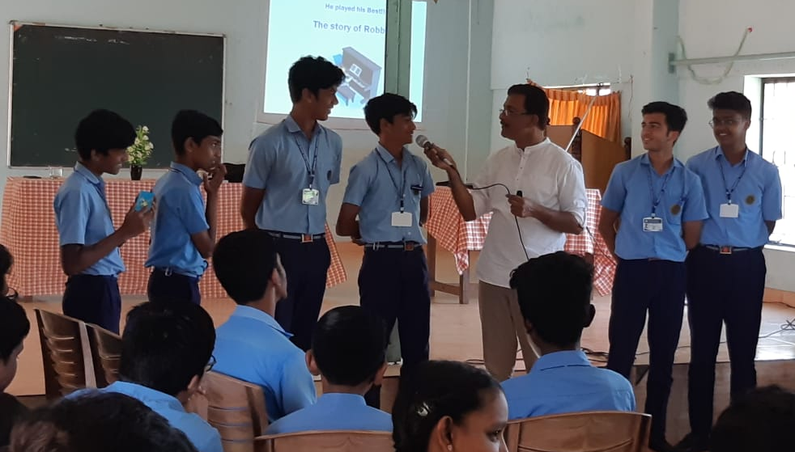
Motivation Class
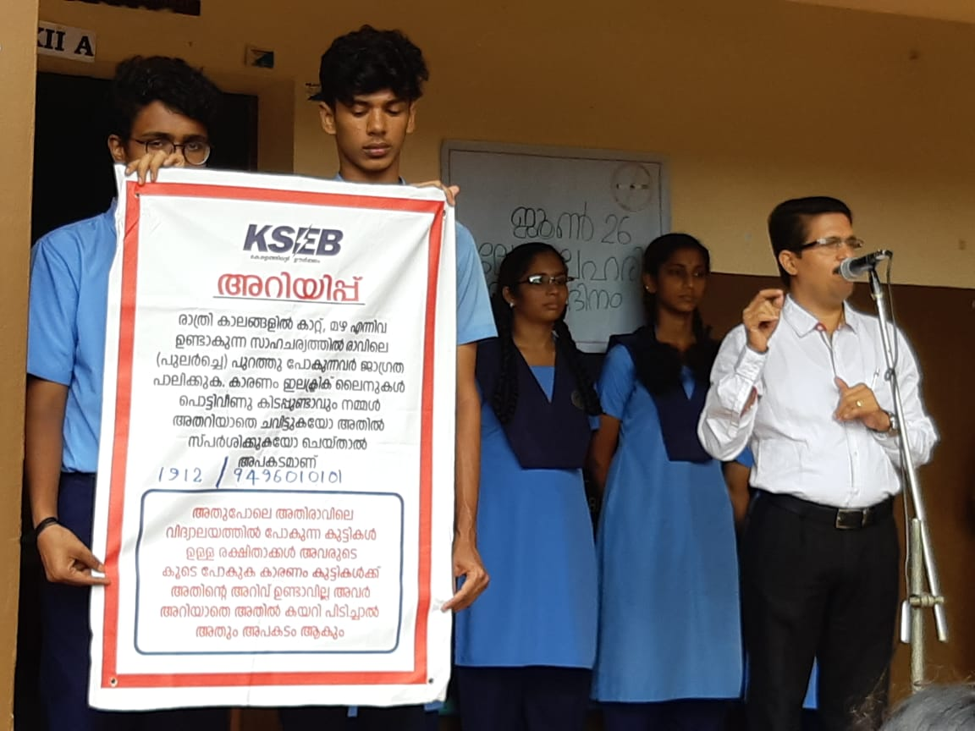
Class by KSEB

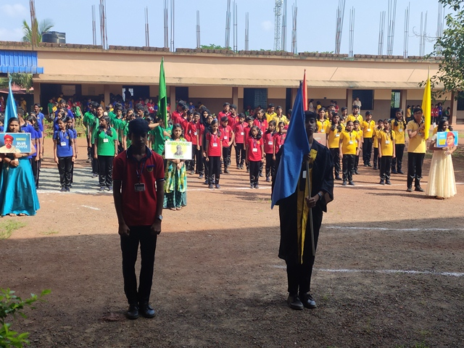
Sports
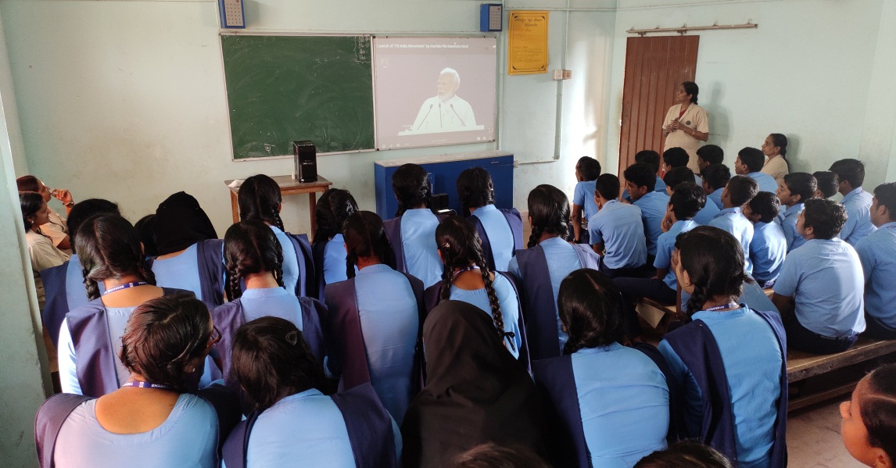
Fit India Program
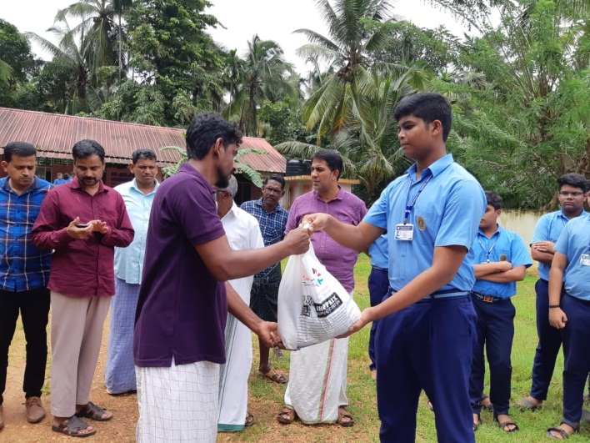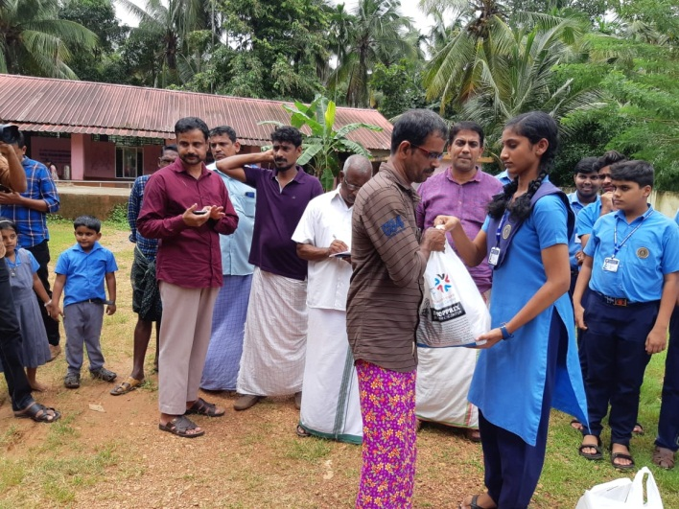
Donation to the flood victims
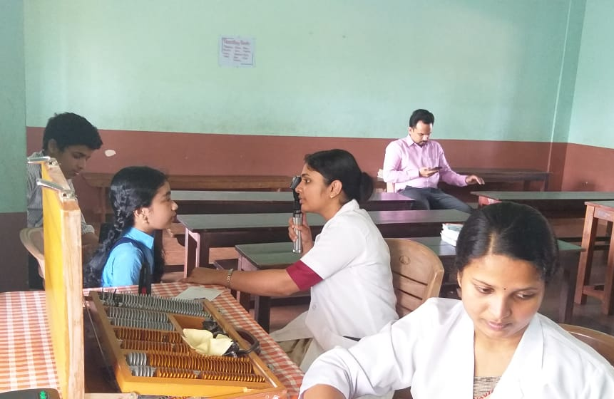
Eye Test Camp
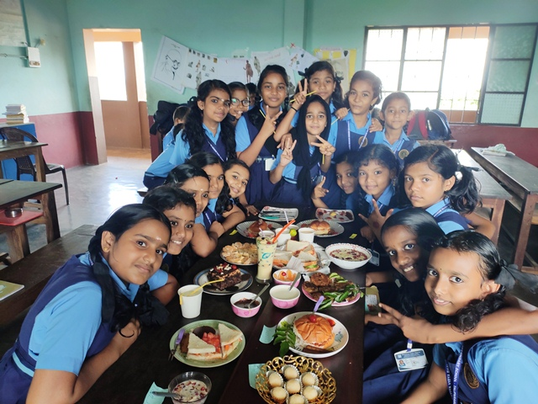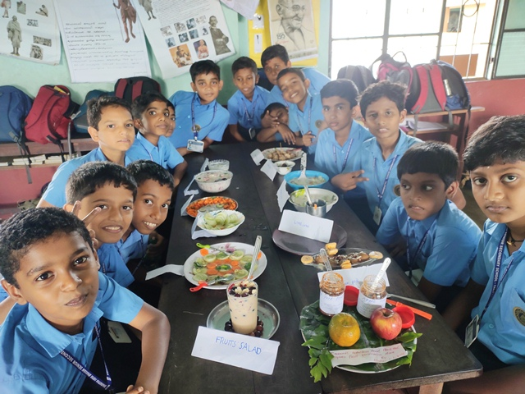
Food Fest
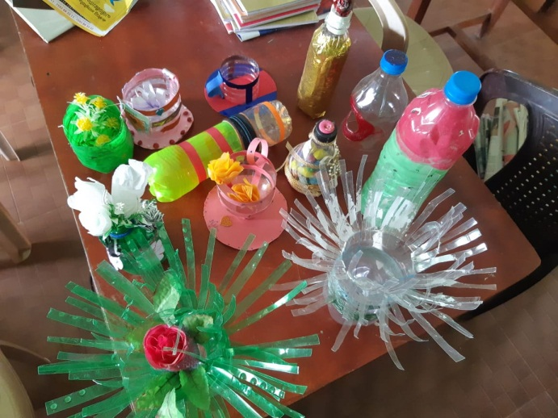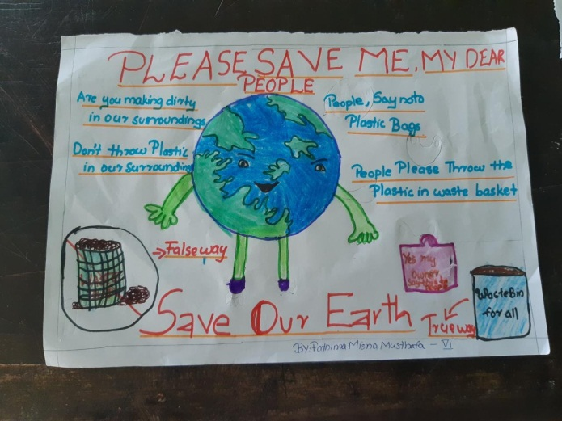
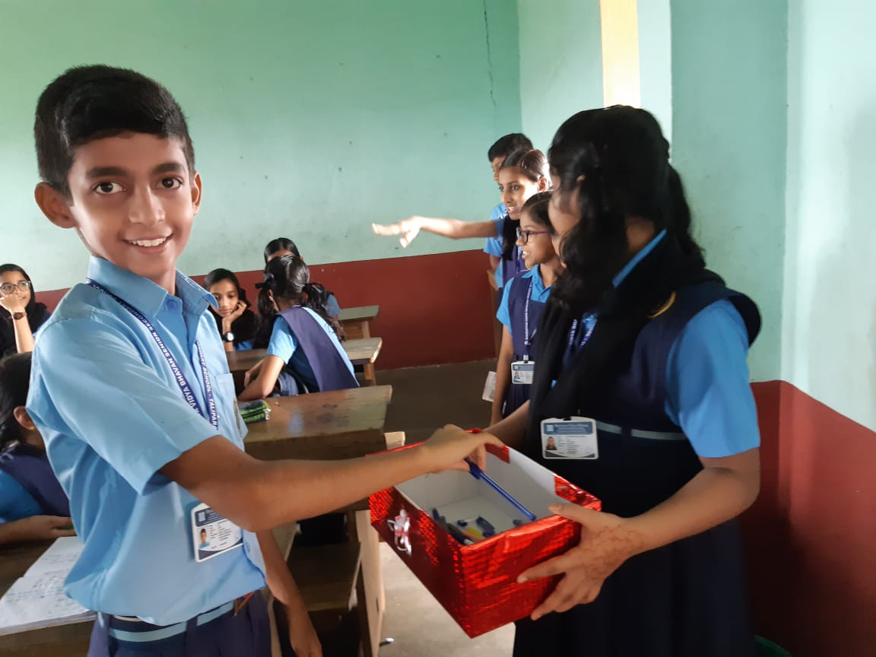
Useless Plastic Campaign
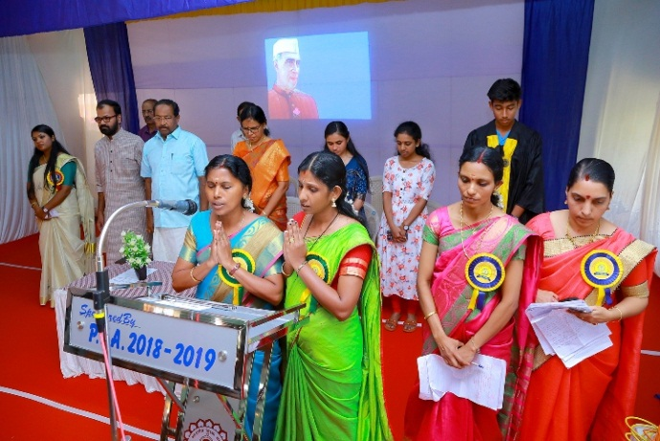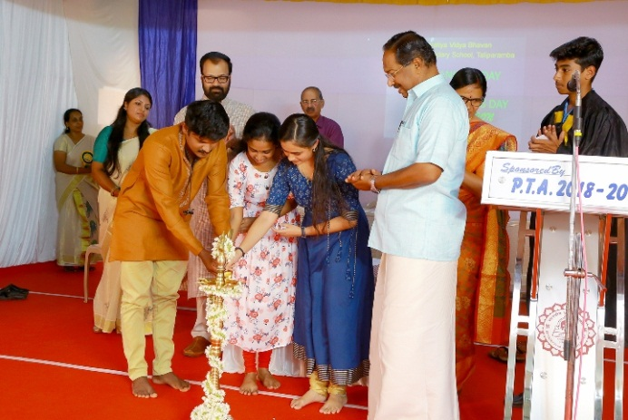
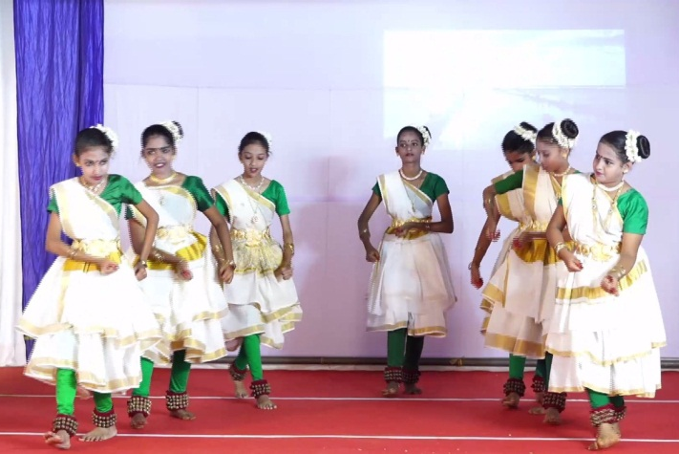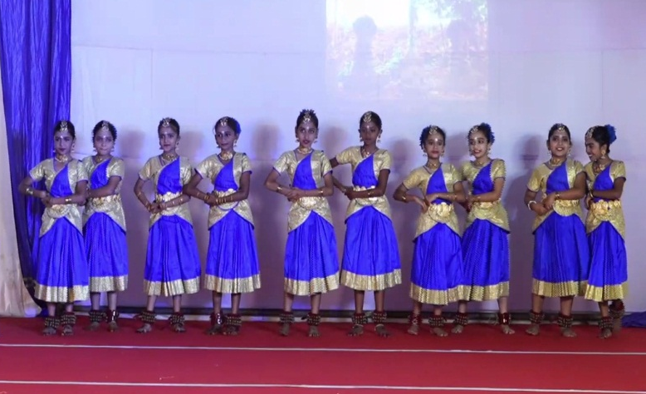
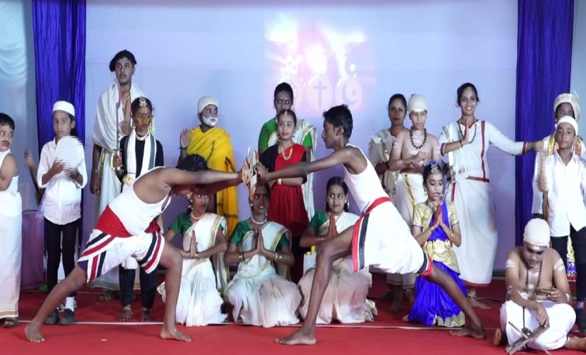

Annual Day

